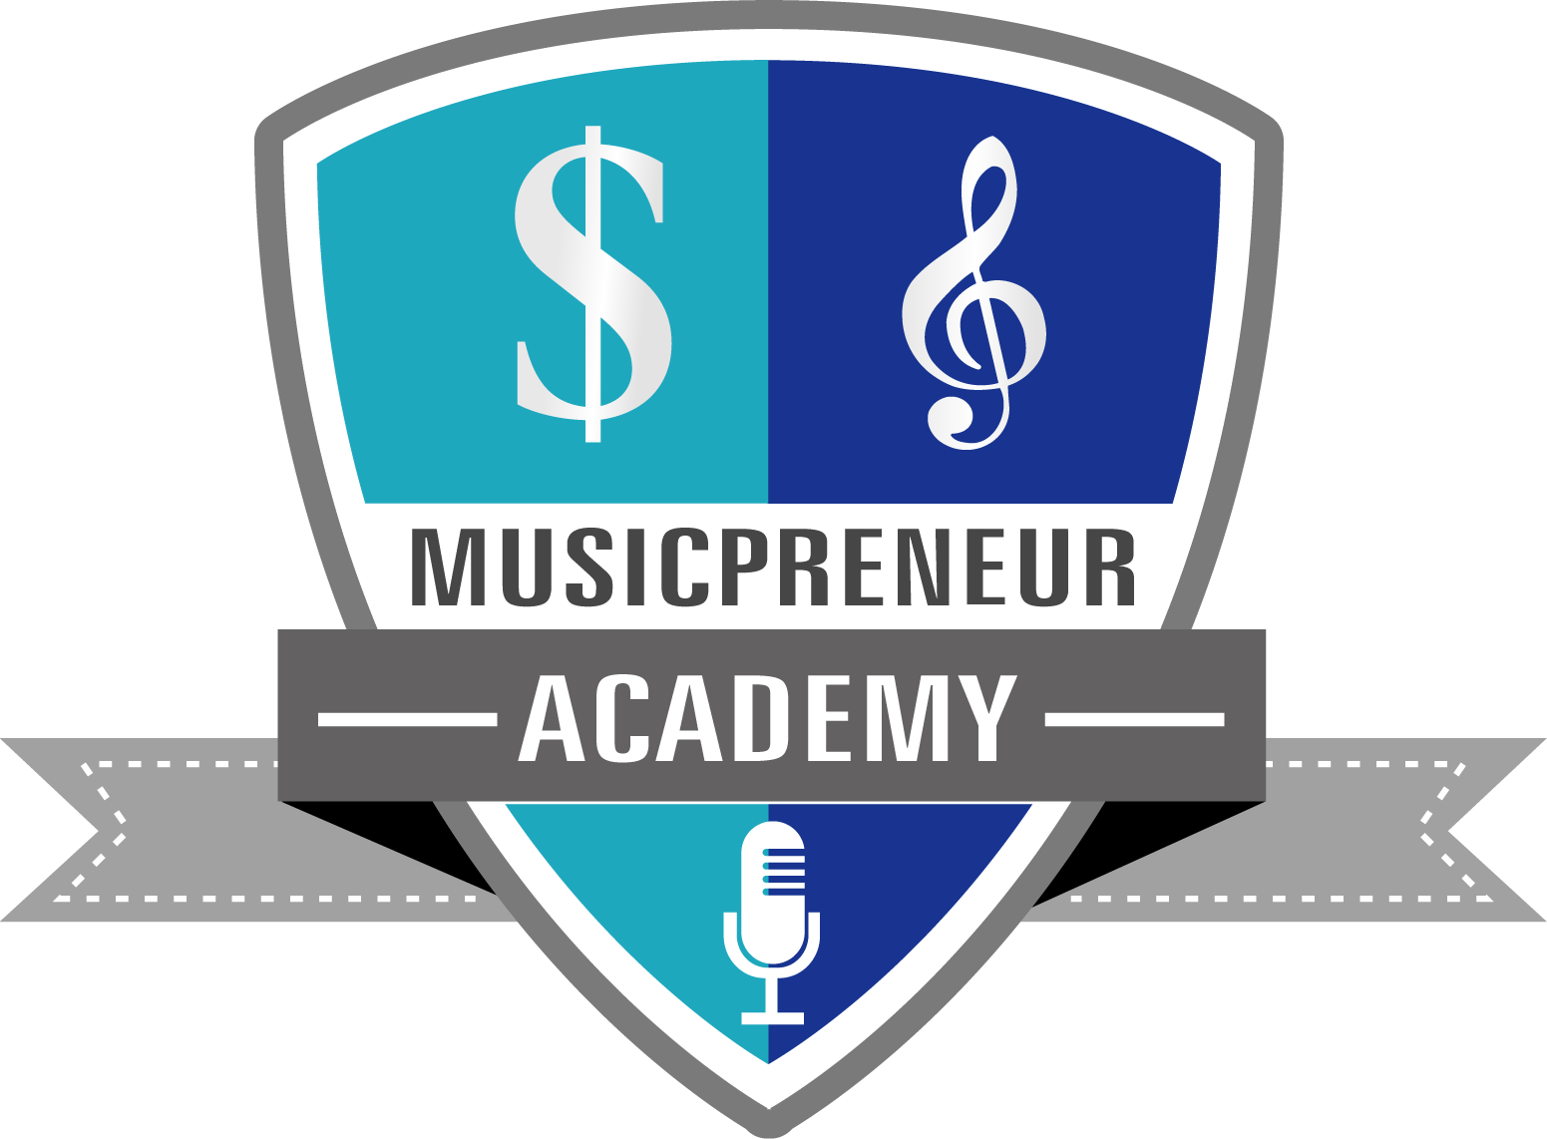

Custom Song Email and Social Media Templates for
Fan Affiliates

1) First email to send to your fans to become affiliates

Note: If you don’t have a way of creating an affiliate link to track sales
(usually through a CRM—Customer Relationship Management system), then you can simply include your custom song website link and ask
your new custom song clients who referred them to you.

Subject line: Get $500 for sharing my custom songwriting!

Hi [First Name],
I’m so grateful for your support of my music, and
to return the favor…

Wouldn't it be fun to receive $500 from me just for
sharing my new custom songwriting business with
your friends? It takes seconds and it's so simple.
As a singer/songwriter, I write and produce
original, radio quality custom songs that are
magical and unforgettable gifts for occasions
like…

Weddings, engagements, anniversaries, birthdays,
and holidays like…

Valentine’s Day, Mother’s Day, Father’s Day, Christmas,
and many other holidays!
I also write songs for speakers, influencers, businesses,
and even conference theme songs! So here’s how it
works…

You send an email to your family and friends about
my custom songwriting (and you can post in social
media). I provide you with an affiliate link to my
website that includes custom song clips, overview
of the creative process, and testimonials.

I will even have a pre-written email and social media
post ready for you to copy/paste and just send! And
the best part is...
If any of your friends order a custom song, you get
$500 from me for EACH order! So think BIG and
make $1,000 or more!
If you want to increase your chances, post your
affiliate link multiple times on social media too!
To hear songs samples, view testimonials, and
discover the custom songwriting process, just
visit:
[Insert your custom song website URL]
If you want to support me by spreading the word
and make some great referral income from me,
just reply to this message so I can send you an
affiliate link and start paying you for custom song
orders!
Thank you so much for your support!

[Your sign off],

[Your name]

NOTE: If you don’t have testimonials yet, consider creating a custom song for a family member or friend for free or a significant discount in
exchange for a great testimonial.

2) Pre-written email for your fan affiliates to send to their contacts

Subject line: Incredible custom song gift idea!
Hello family and friends,
A singer/songwriter friend of mine is offering
something so unique and magical that I just
had to share with you! I've never heard of this
until now.

He/she writes and produces original custom
songs for couples and individuals, and will
even turn it into a custom music video!

He/she will also perform the custom song live
at your wedding, engagement, anniversary,
birthday, private event, etc.
Plus he/she writes songs for speakers,
influencers, and businesses to attract new
customers and inspire their employees!
If you’re searching for an unforgettable
gift idea, I thought you might want to give
someone you love the surprise of their
life!
You will be so touched when you read
his/her testimonials too.
My friend gets pretty booked up with
custom song orders, but he/she has a
couple of spots left.
To hear custom song samples, view
testimonials, and find out about pricing,
just go to:
[Insert your custom song affiliate link]
Let me know if you have any questions
or if you’re interested in ordering a
custom song as a gift or even for
yourself!

[Your sign off],

[Your name]

NOTE: If you don’t have testimonials yet, consider creating a custom song for a family member or friend for free or a significant discount in
exchange for a great testimonial.

3) Pre-written social media post for your fan affiliates to share

My songwriter friend now writes and records original
custom songs for couples, individuals, influencers,
and businesses too!
What a magical and timeless gift for a wedding, Valentine’s
Day, birthday, or even for a podcast or live workshop!
I’ve never seen anything like this and just wanted to
share it with you! What do you think?

If you’d like to know more, just comment or visit my
friend’s site here:

[Insert your custom song affiliate link]

