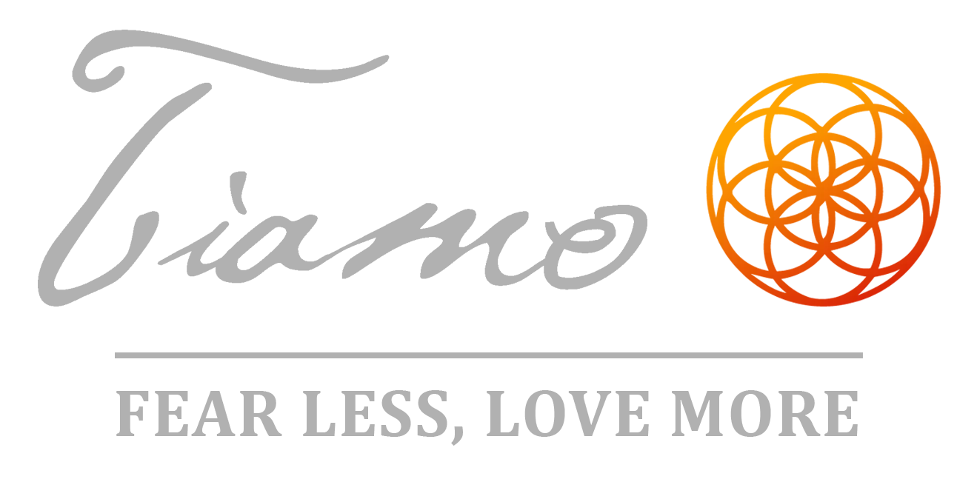

Tiamo Private Concerts: Q&A

What is a private concert?
It’s a live show, but instead of being in a crowded concert venue, bar, club, coffee house, etc., it’s usually in someone’s home. Typically, it’s an acoustic performance. In other words, I perform unplugged—just me and my guitar. If it’s a larger concert (more than 50 people), I may bring a P.A. sound system. In most cases, I perform solo.

This is meant for my music to be the centerpiece of the evening and not background or mood music for a party or event.

What are the benefits of a private concert?
Most people really enjoy when I share the secrets behind my songs, where and how they originated, personal stories, and the open interaction between me and the audience. This creates a much more intimate feel and allows for a casual and fun connection with everyone involved.

Parking is usually free, traffic is minimized, and there are no lines to get in. The audience doesn’t have to wait around for a long time for the headliner to come on and everything has a very natural flow to it. Moreover, this creates an opportunity for the private concert host to create a new, fresh, and inventive social event for their family and friends! It is the ultimate triple-win for the artist, the host, and the audience.

Where will the concert be held?
If you are the organizer, it can be in your home or in the home of someone you know. This way, you could also co-host with someone! It can also be in a public space such as a community room, clubroom, workshop room, lecture hall, theatre, or other rented public spaces.

How many audience members do you require?

At least 20, but ideally 40-50.

What about food and drinks?
Food and drink are not necessary, but will make the event even better and of course, attract more people. A “wine and cheese night” for example works great with my kind of music. Guests can bring wine, cheese, and small desserts.

You can even create a theme. For example, a recent host did a red carpet “Grammy Awards” theme night where people dressed up, had their pictures taken, and the night was a huge success!

You can also keep things simple and make it a potluck or any other ideas that you may have. The extent of this is completely up to you.

What’s your private concert fee?
I normally charge $1,000 for a private concert, but as a private concert host, I will waive the $1,000 fee! My hosts usually charge $20 per guest and I receive 100% of the ticket sales. Sometimes I will arrange with the host to charge $25-$30 per ticket and include my album in the ticket price.

During and after the concert, I require the opportunity to sell my music, merchandise, and other music related services I provide such as custom songs. I also require the opportunity for audience members to become paid monthly fan club members if they choose. I will receive 100% of all music, merchandise, and music services sold.

Host Perks

As an expression of my appreciation to you as a host, I will give you a free copy of my latest album release and a Tiamo “Fear Less, Love More” T-shirt! Plus, I will shower you with love and gratitude—and we’ll get to know each other better too!

What is my role as a host?
I will be counting on you to organize the event, invite the guests, and provide the space. We will work together as a team so you feel supported during the process.

I encourage you to create a page where people can RSVP and pay in advance (like EventBrite.com), have a Facebook event page, and be creative in how you promote the event so we get a positive turn out.

You can invite family, friends, neighbors, co-workers, etc. Other things to think about are best dates and times, where people will sit during the concert, how many people will fit in the space provided, parking, etc.

If you decide to become a host, you and I will have a couple of calls well in advance where we discuss the details and talk about how we can make this a wonderful event!

Thank you

Thank you for your interest in hosting a private concert! While there are a few details involved, this is meant to be fun, creative, and exciting for everyone!

This is simply a general guide to widening your understanding of my private concerts. At the same time, I encourage you to be as original and unique in your planning as you feel inspired. Together, my goal is to co-create a magical and unforgettable evening where your guests walk away feeling like they had an amazing time, I feel fulfilled as an artist, and you feel like a private concert host rock star!

Please let me know if you have any questions and thank you again!

In gratitude,

Tiamo :)

